

**A passion driven state of innovation**

**“**Innovation into creation of websites, architecture and global infrastructure of the company thrives the impact on global audience. The specialty of developing the best across the globe is the competition of this decade and our motive is to bring dawn to the new era in “Website Development & Infrastructure”.

**Project Title** : Truinal Proserve 2.0

**Project Lead** : Mr. Peter Sedrak

**Purpose** : Internship Course

**Interns involved**: 19

**Duration** : January 11th 2017 – May 9th 2017

**University** : Valparaiso University, Valparaiso, Indiana

***Approval of project by***

**Mr. Peter Sedrak**

**Table of Contents**

1. **Company Description**
2. **Senior Management**
3. **Organizational Chart**
4. **RACI Chart**
5. **Development of Wire -Frames**
6. **Life to a Website**
7. **Project Tracking**
8. **Time Tracking**
9. **Automation and Testing Policies**
10. **Accomplishments**
11. **Lesson Learnt**
12. **Company Description**

**Truinal ProServe Corporation** is a product and service oriented industry currently operating in North America and South America since 2009. The company also has operations in Africa and India as a part of business growth and diversity. Our business architecture is based on accomplishments in development of software and websites. Furthermore, by supporting the clients with the product developed through the technical and manual support wherever and whenever required for the successful project outcome. The newly started subdivision at California is competing to take on the present market.

* Has operations in Africa, India.
* Corporate office is located In California.
* Business Type: Product and Service based Industry
* Business Address: 1500 Dungeon St, Bay Area, CA
* Annual Sales: $75million
* Number of Employees at head office: 19
* Total Number of Employees: 40

**Mission:**

*“To develop software and website as per the client requirement with the best quality.”*

**Vision:**

*“Our company is focusing on increasing the turnover to $1000 million by 2020 by expanding the product services and employee capacity.”*

**Values:**

*“The company core values include reliability, integrity and uniqueness for the products and services offered.”*

**Success Stories:**

**“IBM** has reported increase in their clients and customer’s appreciation for the design of UI as it is attracting the eyes of the investors, helping the business to improve for they marker for. Increase in 10% of revenue generated this fiscal year 2017 in product and services sector.”

**“Deloitte** implemented the latest audit report from external sources and mitigated their main breach of risk, resulting in successful year for the fiscal year 2016.”

“**Genpact** reported 5% increase in Business process operations for operating state of art in website managing usage and database management process, creating a new market in the competitive space”.

“**Accenture** struck by huge hurricane on January 22nd, 2015 and their data center located at Tampa, Florida was destroyed. However, their redundant data center newly developed helped their process to run smoothly from the extravagant support by Truinal ProServe Technologies.”

***Inside Truinal Technologies***

1. **Senior Management**



PETER SEDRAK

CEO

##### Peter Sedrak a natural leader with a record of delivering enhanced productivity. An Accomplished manager with 10+ years’ experience and a verifiable record of delivering enhanced productivity, streamlined operations, and improved financial performance. Peter was appointed as the CEO of Trunial ProServe in the year 2010, he has completed his Bachelors in Systems Analysis and Design from Purdue University and MBA – Management Technology from University of Phoenix. In 2004, he received the Professional Television Production Awards and the No Rework Award - Baldridge Quality Initiative. Prior to this job he has worked as Senior Change Problem Analyst in Health Care Service Corporation and Senior Database Analyst in ABN AMRO.

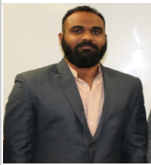

NAVEEN REDDY BANDAKUNTA

PRESIDENT

Naveen Reddy currently works as the President of Trunial ProServe Technologies. As part of his previous works he has co – founded mindworkz where students where taught about new emerging technologies. Naveen has done his Bachelors in Computer Science from Jawaharlal Nehru Technological University, Hyderabad, India and Masters in IT from Valparaiso University, Indiana, USA. He has prior work experience in development and management and worked as a Director and Senior Director in Data Smart. Also co – founded Promaze Consulting Private limited and was appointed as Head of Marketing and Business Development.



RINCY SUSAN MATHEW

BUSSINESS LIAISON

Rincy Susan Mathew was elected as the Liaison for Trunial ProServe in the year 2015. Rincy has a more global experience of living, working and studying in different places throughout her life. She has completed her Bachelors in Computer Science and Engineering from Sathyabama University, Chennai, India and her Masters IT –Management Track from Valparaiso University, Indiana, USA. Also she has a previous work experience as an Operations Manager in RAKBANK, Dubai. As a student also Rincy was the cultural head for her university functions. All these managerial and communication skills have lead to her current position as the Liaison. She plays the prime role of the person who liaises between two teams or organizations and coordinate their activities.

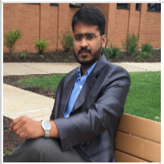

ABHILASH GUDIPUDI

VICE PRESIDENT OPERATIONS

Abhilash Gudipudi a motivated leader to communicate, build teams and aspire to be the best tech-savvy every day. Accomplished delivery of projects to clients on time and helped internal teams to be the best in Technology. Abhilash Gudipudi has technological skills in Devops, IT operations for 8+ years and was appointed as Vice President of Truinal ProServe in 2010. He has a Master degree in IT- Management from Valparaiso University and a Bachelor’s degree in Electrical Engineering from JNTU- Hyderabad. His continuous efforts to lead teams, interacting with every employees makes him stand out as the most admired employee within the organization on a personal scale.

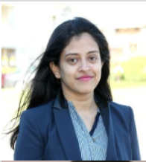

NISHITA YELURIPATI

VICE PRESIDENT CREATIVE

Nishita Yeluripti appointed as the Vice President Creative to manage and deal all the companies development of websites and software creativity. She has graduated from Valparaiso University with a Masters in IT – Computing. Nishita completed her project in digital image processing for kinetic object which helped her pursue her career in the creative field and also worked in my different position for different organizations. Her leadership approach helped her achieve the current position she is in. She works with a team of creative people with many innovative and creative ideas which helps the organization to win many awards under her leadership.



NAGA GOPALAPURAM

VICE PRESIDENT ADMIN

Naga Gopalapuram has been appointed as the Vice President Admin of Trunial ProServe Corporation from the year 2015. After completing his Bachelor’s Degree from JNTU – Hyderabad, India in 2014 he went further to work with Tribio Soft Tech based in India for a almost one year. The role played by him was of an administrative officer and got promoted as the Administrative Manager in a very short span of time. In his current position as the Administrative Head, he serves as the lead for any official works involving external and internal projects such as Workforce, Networking, Database administration and Management.

1. **Organizational Chart**

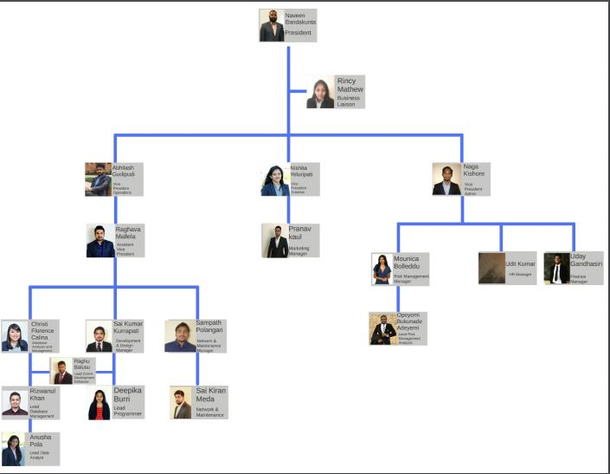

**Note:** For any information regarding any of the intern can be contacted to Business Liaison Office and further referred to the HR Department to disclose the information (**Client use only)**

1. **RACI Chart**
2. **Development of Wire –Frames**
3. **Life to a Website**

The life to the website is not restricted to the creation or innovation, all programming intern teams worked together throughout the projects to build internal website pages and external website pages.

The internal website is particularly for employee login and totally for the purpose of the organization and it also helps in employee network to be isolated from the network.

The external website is to bring the company’s reputation and achievements to global audience, also to attract clients for the work we do and what we do.

**INTERNAL WEBPAGE**

As a part of the network, every company needs an internal website where we and our co-workers share files and other necessary information. Generally, the internal website looks like the regular website. For instance, when you open the regular website and the internal website of the company has the same search button on the left side. There are many links to the website likely how we use the website for the employees. There are things you can do through the internal website or the web page. As the issues seem to appear, you can request the help desk for the issues and submit them. There are many other announcements, view the projects and the discussions and other related topics for the internal web page supposed to have.

The website should look and quality rate should be maintained. The overall quality and the effectiveness of the internal webpage must be excellent. The internal webpage must include the professional web design features, and well-written, fine images and interactive content. The technologies used are the HTML, CSS that are well built and the website looks so professional and the content that helps for the members in the company. The Hypertext markup language (HTML) is used for the building the website or designing the website for the user convenient manner. The internal webpage can be elegant and visibility throughout the page.

**INTERNAL WEBPAGE**

As a part of the network, every company needs an internal website where we and our co-workers share files and other necessary information. Generally, the internal website looks like the regular website. For instance, when you open the regular website and the internal website of the company has the same search button on the left side. There are many links to the website likely how we use the website for the employees. There are things you can do through the internal website or the web page. As the issues seem to appear, you can request the help desk for the issues and submit them. There are many other announcements, view the projects and the discussions and other related topics for the internal web page supposed to have.

The website should look and quality rate should be maintained. The overall quality and the effectiveness of the internal webpage must be excellent. The internal webpage must include the professional web design features, and well-written, fine images and interactive content. The technologies used are the HTML, CSS that are well built and the website looks so professional and the content that helps for the members in the company. The Hypertext markup language (HTML) is used for the building the website or designing the website for the user convenient manner. The internal webpage can be elegant and visibility throughout the page.

**EXTERNAL WEBPAGE**

A webpage is basically a document that is suitable for the World Web Browser. The external webpages there are many external links that are associated in the website. The tools used in the external web page are the OpenBEXI Development tool, Dreamweaver CC 2017 and the technologies used are HTML5, CSS6, JavaScript. The OpenBEXI is a WYSIWYG HTML builder using the magic of HTML5 and CSS. It is easy to build the webpage. This will allow to edit the texts, images and the widgets. The OpenBEXI integrates the web browser and helps for the input forms validations and that helps the developers to quickly develop the website and the web based applications.

The Dreamweaver CC is the world's most complete tool for web designers and front-end developers. It combines a powerful design surface and best-in-class code editor with robust site management tools, for you to easily design, code, and manage websites. This tool is live view and the code editor which helps to edit the code with syntax highlighting and the code completion and the syntax checking.

The Technologies HTML5, CSS6 and JavaScript are most prominently used technologies to build the webpage. Technologies used in the external webpage are the updated version. The front end used technologies are HTML5, CSS6 and back end is JavaScript.

1. **Project Tracking**

1. **Time Tracking**

Time tracking helps in look up to the performance and time management of teams that delivers efficiency, also thrives on completing the project on schedule by delivering the required objects to the client.

Our team worked on time tracking by building a block of codes specifically 1208 lines of code by learning .NET and applying the same through a logic

This application is used to log the details of work time involved by the interns and maintained by the time tracking team.

**Details of Code:**

**Start of Code:**

<script type="text/javascript">

**var** startTime = **new** **Date**();        //Start the clock!

   window.onbeforeunload = **function**()        //When the user leaves the page(closes the window/tab, clicks a link)...

   {

**var** endTime = **new** **Date**();        //Get the current time.

**var** timeSpent=(endTime - startTime);        //Find out how long it's been.

**alert**(timeSpent);        //Pop up a window with the time spent in microseconds.

   }

</script>

<script type="text/javascript">

**var** startTime = **new** **Date**();        //Start the clock!

   window.onbeforeunload = **function**()        //When the user leaves the page(closes the window/tab, clicks a link)...

   {

**var** endTime = **new** **Date**();        //Get the current time.

**var** timeSpent = (endTime - startTime);        //Find out how long it's been.

**var** xmlhttp;        //Make a variable for a new ajax request.

**if** (window.XMLHttpRequest)        //If it's a decent browser...

       {

           // code for IE7+, Firefox, Chrome, Opera, Safari

           xmlhttp = **new** XMLHttpRequest();        //Open a new ajax request.

       }

**else**        //If it's a bad browser...

       {

           // code for IE6, IE5

           xmlhttp = **new** ActiveXObject("Microsoft.XMLHTTP");        //Open a different type of ajax call.

       }

**var** url = "http://anything.com/time.php?time="+timeSpent;        //Send the time on the page to a php script of your choosing.

       xmlhttp.open("GET",url,**false**);        //The false at the end tells ajax to use a synchronous call which wont be severed by the user leaving.

       xmlhttp.send(**null**);        //Send the request and don't wait for a response.

   }

</script>

<?php   
header("Expires: Mon, 26 Jul 1997 05:00:00 GMT");   
header("Cache-Control: no-cach");   
include("./connect.php");        //Connect to the database.   
mysql_query("INSERT INTO  `your_table_name` (`time`) VALUES ('".$_GET["time"]."');");        //Add them to the db.  
?>

**End of Code**

1. **Automation and Testing Policies**

**Purpose:**

Testing subjects to front end logic/end-end program testing after the code is build, will be further tested for errors and shall be reported back to the developer’s team for further improvement of the code.

**Scope:**

To provide end users with effective build software after release and extend quality assurance after the build release.

**Procedure:**

Software Build will be tested with tools that are built on from the foundation, such as Apache Server, Workbench, MySQL, PHP Client and furthermore will be updated as per the project iterations.

**Test Scope:**

1. Once a code is tested is tested, upon upgradation of the code only the feature is considered and tested.
2. Software is only tested and reciprocators are suggested but not built.
3. Tester can be suggested or guided with the use of specific software and specific versions for successful test of the build.
4. Delivery of test report is subjected to complexity of the code, duration will be tentatively changed ranging from 2-5days.
5. Head Developer will be a hawk eye for the entire process of testing phases for successful client deliverable satisfaction and reduce redo or time complexity.
6. **Test scope is subjected to change any time depending on the time complexity or further modifications of rules and guidelines.**

**Risk and Process of Mitigation:**

If process of build fails, it will not affect the iterations or delay of the project as head developer and testers will deliver with sufficient changes from either end, delivery time depends on complexity of issue.

**Exit and Suspension Criteria (Testers only)**

Upon certain feature or code is informed changed from developer end or causes warning at a certain point can be halted and revert it back to developers.

Successful 3 attempts of code testing is claimed passed and testing criteria is subjected to change test to test, process of test will be reported in individual deliverables only.

**Deliverables:**

Document of test report, sample of version used will be mentioned and will be forwarded to Head Developer and Project Trackers, will not be forwarded to teams at any cause from tester end.

Accessible to CEO, Senior Director, Business Liaison, Vice President of IT Operations.

**Result:**

Final approvals are subjected to Senior Director, Project Tracker and test is considered accomplished.

Samples are further stored for future references and lesson learnt are saved entirely for the benefit of the organization as a knowledge source.

1. **Accomplishments**
2. **Lesson Learnt**

##### 